**Co-modulation of heart rate variability and language**

**Mayara dos Santos Nascimento**

**André Fujita**

Institute of Mathematics and Statistics of the University of São Paulo

mayara_santos@usp.br

**Objectives**

Human beings have the unique ability to communicate and extract meaning through spoken and written language. And such language processing is one of the most complex cognitive tasks that humans routinely engage in.

To explore the heart rate and behavior of social interaction, this research project aims to assess the interaction between two or more individuals. In this work, we reviewed studies on neural mechanisms and markers of social interactions, however the research bias was based on performing a behavioral experiment via analysis of heart rate variability.

**Methods and Procedures**

In this work, the behavioral experiment described by Dikker [1], in which 10 speakers and 10 listeners will be selected, all men, right-handed and aged between 20 and 40 years.

All participants must have normal or corrected-to-normal vision, and no history of psychiatric or neurological disorders, free from any psychotropic medication.

During the experiment, those selected will be asked to view 45 hand-drawn color images depicting fictional scenes in which an animal or object performs an action on another animal or object (for example, a penguin hugging a star). Scenes were built based on phrases that will be created through random combination of 45 transitive verbs and 90 nouns, denoting common objects, animals and foods. The speaker will be instructed to describe the images, using declarative sentences, simple in the present continuous tense, with a single transitive verb and without adjectives or adverbial phrases.

Each image was assigned a predictability score, derived from an online questionnaire in which 40 volunteers described each of the 45 scenes with the description they considered most appropriate. None of these 40 volunteers will participate in the experiment. For each scene, we assigned a score reflecting the percentage of participants who entered the same answer. Predictability is given by 1 minus the entropy value, with 0.0 being the least predictable and 1.0 the most predictable. Based on the distribution of predictability, items will be assigned one of two conditions: high predictability and low predictability.

We asked participants to indicate on a scale of 1 to 5 how certain they were that other people would also enter the exact same sentence. The sentences will be described by the speaking participants during the sessions of the face-to- face experiment, and will be simultaneously heard by the listeners during the capture. Then, for both the speakers (N = 10) and listeners (N = 10), we will present each image for 7.5 seconds, followed by 7.5 seconds of blank and then intermittent fixation crosses (375 ms on /off, 3 seconds total).

Then the display of the next image begins. Each participant will see a total of 45 trials in random order, distributed in five blocks. Each session will last approximately 45 minutes and in parallel, heart rate will be captured by Polar H10 electrocardiogram sensors.

**Results**

For the captures, a software was built, whose main characteristics are:

•It has an operator window, where the beginning of the capture is controlled.

•Allows you to establish the capture routine, image display time, pause, etc.

•Has windows for volunteers, where the images and instruction message are displayed.

•Displays the images contained in a folder randomly.

•Saves the electrocardiogram signal.

•Automatically locates available cameras, and electrocardiogram sensors on localhost and other hosts on the network.

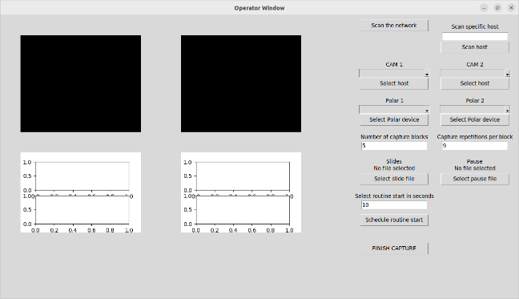

Figure 1: Operator window

Figure 1 shows the capture of the operator window that will control the data acquisition in the face-to-face experiment.

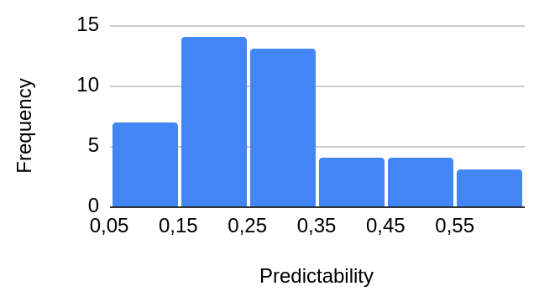

Figure 2:Frequency of predictability

Figure 2 demonstrates the histogram constructed from the predictability coefficient calculated based on the online experiment.

**Conclusions**

So far the software has been implemented and the predictability indexes of the images have been calculated, the dataset acquisition will start in the second half of September.

**Bibliographic references**

1.Dikker, Suzanne, et al. "On the same wavelength: predictable language enhances speaker–listener brain-to- brain synchrony in posterior superior temporal gyrus." Journal of Neuroscience 34.18 (2014): 6267-6272.

2.Dale, Anders M., Bruce Fischl, and Martin I. Sereno. "Cortical surface- based analysis: I. Segmentation and surface reconstruction." Neuroimage 9.2 (1999): 179-194.

3.Dikker, Suzanne, et al. "Early occipital sensitivity to syntactic category is based on form typicality." Psychological Science 21.5 (2010): 629-634.

4. Sänger, Johanna, Ulman Lindenberger, and Viktor Müller. "Interactive brains, social minds." Communicative & integrative biology 4.6 (2011): 655-663.

5.Bergerbest, Dafna, Dara G. Ghahremani, and John DE Gabrieli. "Neural correlates of auditory repetition priming: reduced fMRI activation in the auditory cortex." Journal of Cognitive Neuroscience 16.6 (2004): 966-977.